QUILT AUCTION

ST. CECILIA PARISH / CITIZENS CIVIC LEAGUE
Civic League Park – Meta, MO

SUNDAY, JULY 10, 2022 - 4:00 p.m.

Baby Quilts

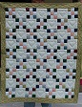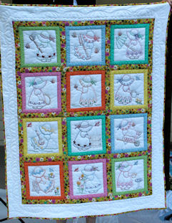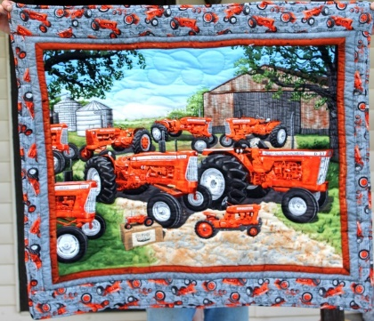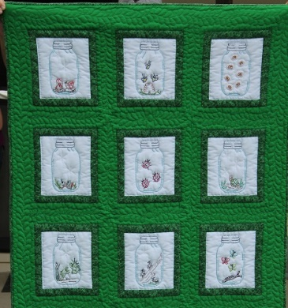
Nine-Patch & Hearts Sunbonnet Girls Allis-Chalmers Creatures In Jars
43 x 53 42 x 53 41 x 47 45 x 60

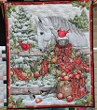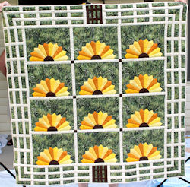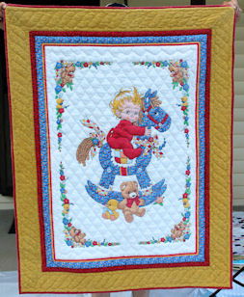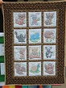
Cardinals & Friend Kansas Garden Baby on Rocking Horse Forest Friends
35 x 43 57 x 57 43 x 55 37 x 50

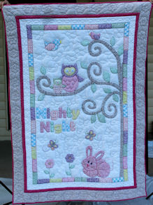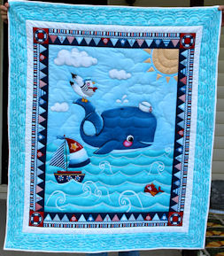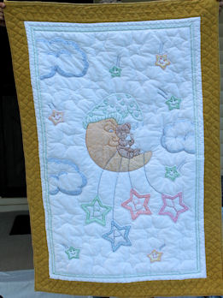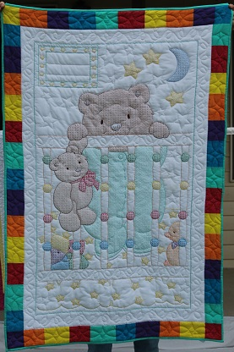
Owl & Friends A Whale of a Time Bear on the Moon Peek-A-Boo
47 x 67 46 x 55 44 x 64 43 x 65

The St. Cecilia Parish reserves the right to hold auction items until a monetary transaction has been completed.

Auctioneering Services Donated by Hurst Auctioneering

All Sales Are Final

