QUILT AUCTION

ST. CECILIA PARISH / CITIZENS CIVIC LEAGUE
Civic League Park – Meta, MO

SUNDAY, JULY 10, 2022 – 4:00 p.m.

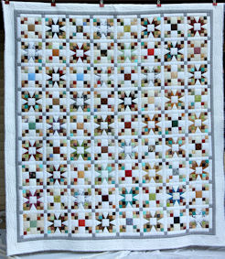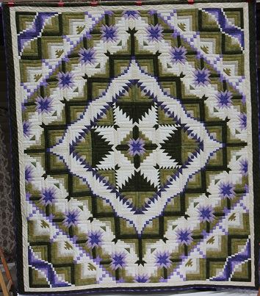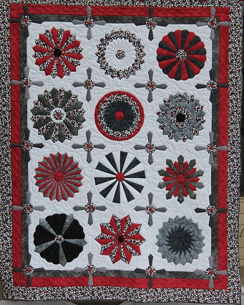
Square Dance Eureka Starburst Dresden
99 x 110 100 x 116 85 x 107

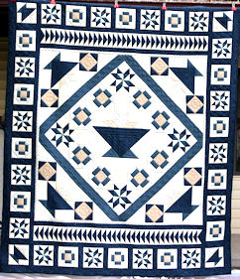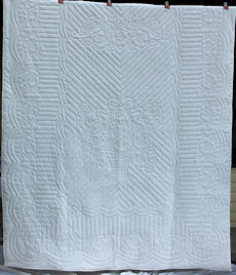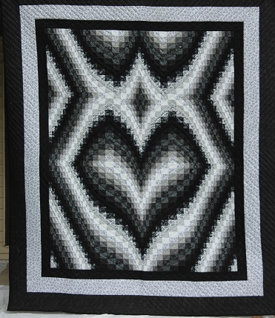
Crossroad Blues Rose Basket & Butterflies Heart Bargello
98 x 113 94 x 108 100 x 117

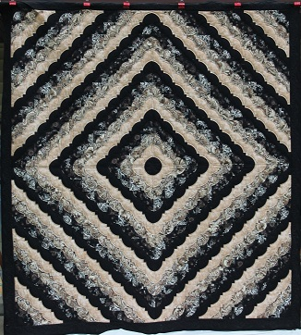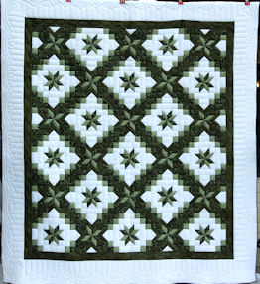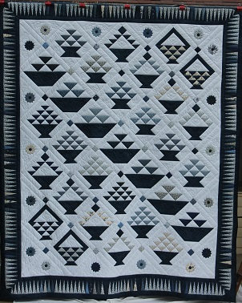
Love Ring Star In Chain The Gathering
104 x 112 112 x 111 97 x 116

The St. Cecilia Parish reserves the right to hold auction items until a monetary transaction has been completed.

Auctioneering Services Donated by Hurst Auctioneering

All Sales Are Final

