QUILT AUCTION

ST. CECILIA PARISH / CITIZENS CIVIC LEAGUE
Civic League Park – Meta, MO

SUNDAY, JULY 9, 2023 – 4:00 p.m.

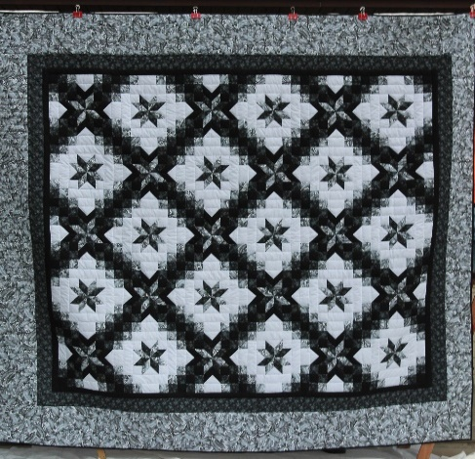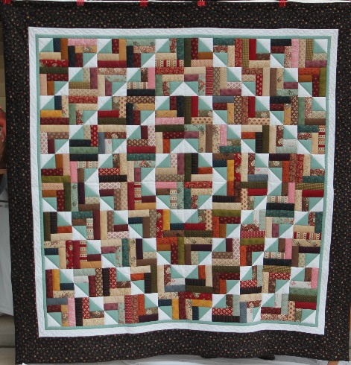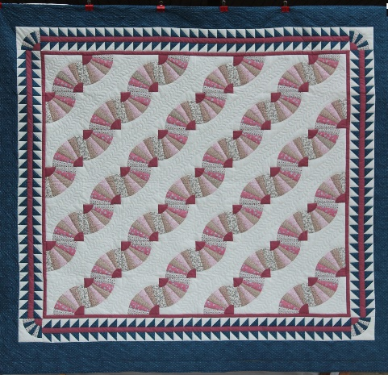
Star In Chain Summer Camp Field & Furrows
100 x 112 101 x 103 98 x 108

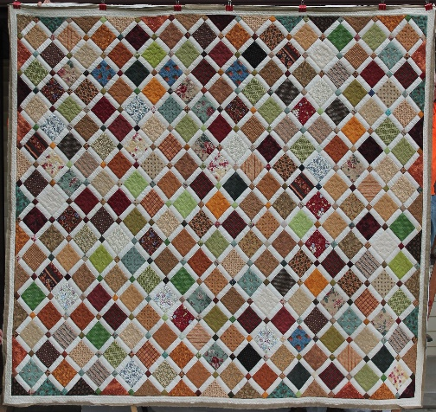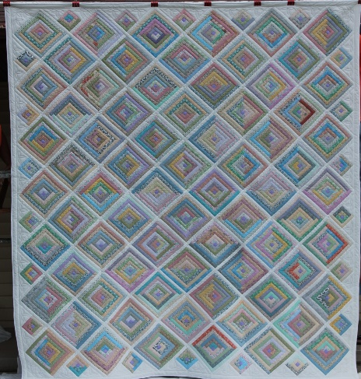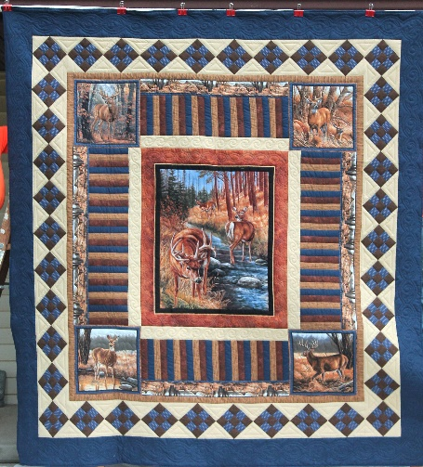
Delightful Days Cotton in the Cabin Wildlife Refuge
106 x 125 105 x 122 102 x 109

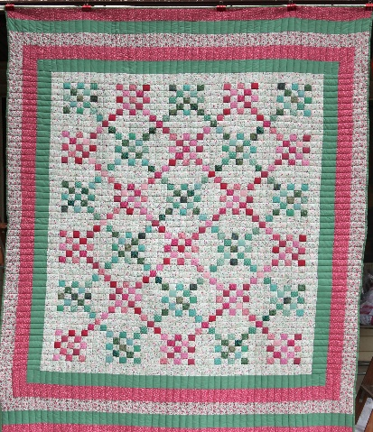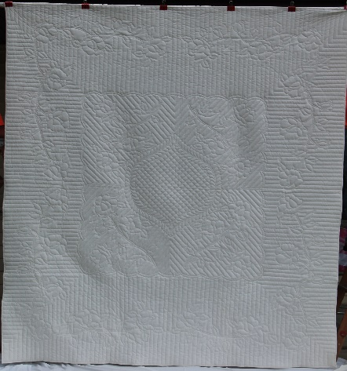

Special Dessert Auction
will follow
Quilt Auction.
Blocks In Chain Roses
85 x 110 94 x 108

Auctioneering Services Donated by Hurst Auctioneering

All Sales Are Final
The St. Cecilia Parish reserves the right to hold auction items until a monetary transaction has been completed.

